Profile  EQUITY: 00476963  Contact  PHONE: 07983 551007  EMAIL:  equitydrewsinclair@gmail.com  WEBSITE:  Home | My Site (drewsinclair.co.uk)  SPOTLIGHT:  https://app.spotlight.com/6297-8949-4136  Main Musical Influences:  Meatloaf  Queen  Bon Jovi  Def Leppard  Take That  Backstreet Boys  Elton John  Phil Collins  Hobbies  Chesterfield Gilbert and Sullivan Society  Cantiamo: Vocal harmony group  EYES: BLUE  HAIR: Ash Blonde  HEIGHT: 5’7’’  WEIGHT:11s 04b  PLAYING AGE: 30-45  SINGING: Tenor/Countertenor |  | Drew Sinclair  Actor/Singer  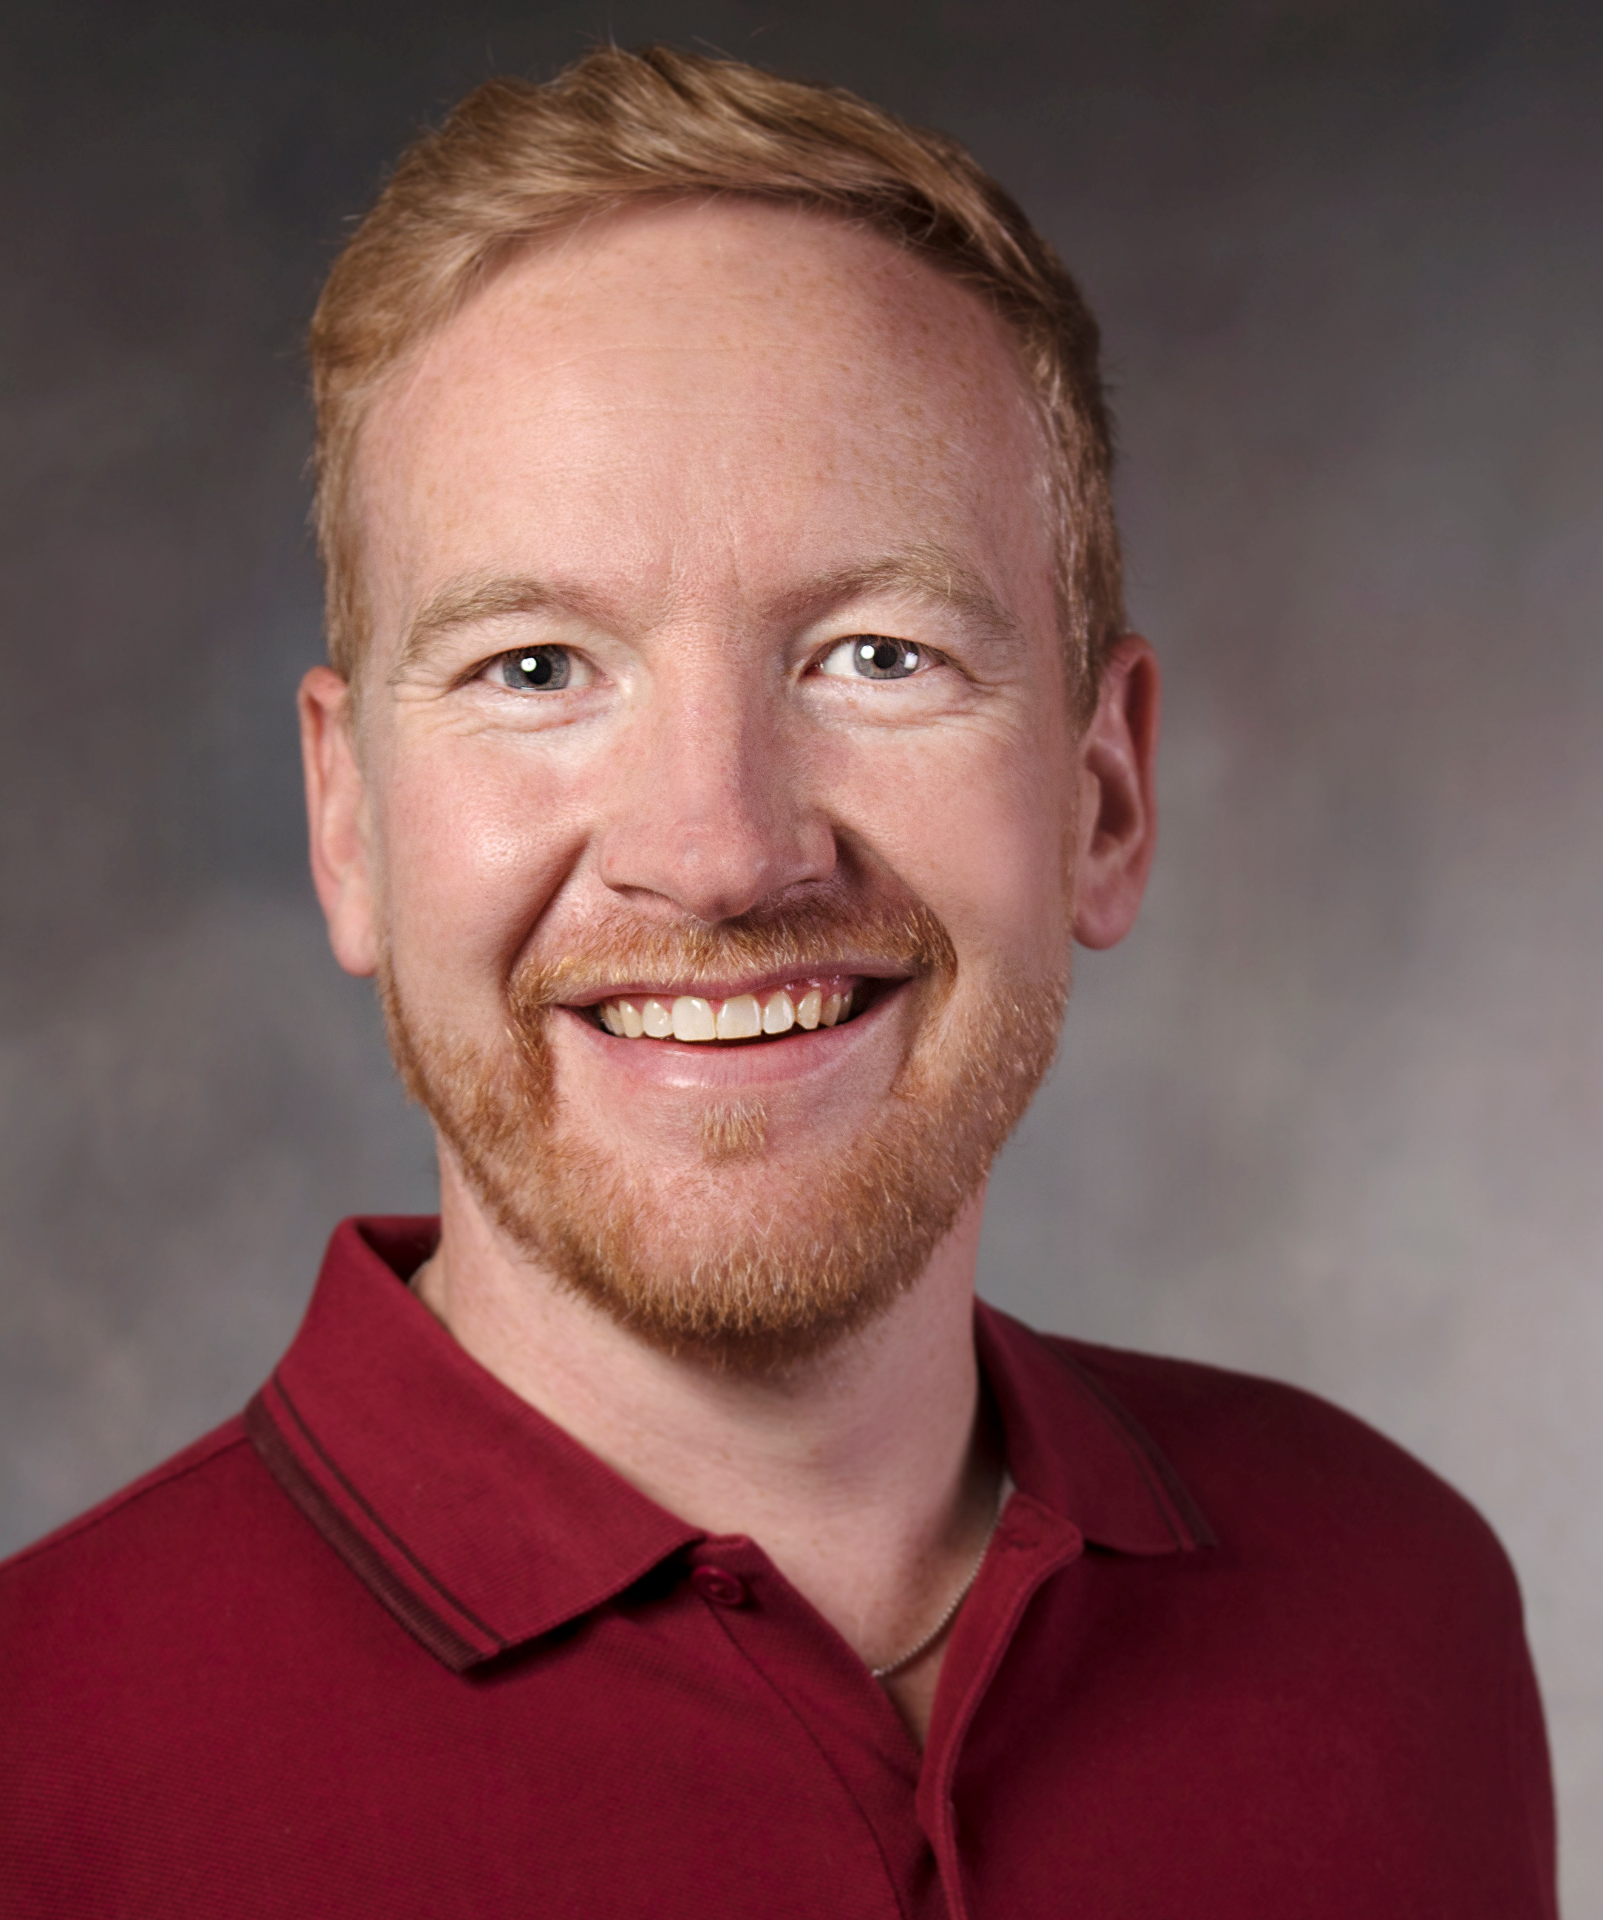  Sheffield College  2021 - 2022  Foundation Degree Arts- Musical Theatre  Classification - Distinction  Hallam University  2022 – 2023  BA (Hons) Acting and Performance  Classification 2:1  Professional Work (Paid)  2025  The Odd Squad - CBBC  Character - Villain Cloudy Claude  Season 5 - 2 x episodes  2025  All Creatures Great & Small  Character - Walk on-featured role  A Channel 5 TV Series (First aired in 1978 for the BBC)  2025  The Trial of Paul Burrell  Character - PC Ward - Witness  Channel 5 - Good Tv  2025  THE LOCK IN - By Nathan Geering  Character - Drew  Indi Feature Film - Kung Fu Action Comedy  2024  Gilbert & Sullivan National Opera  Buxton Fringe festival 2024  Ensemble and Foreman in ‘Trial by Jury’  Director – Nei Smith  2024 The Trial of Steve Wright  Good TV- Ch 5 Crime Documentary  Peter Wright Lead Barrister  Director – Tom Harrod  2024 The Trial of Harold Shipman  Good TV- Ch 5 Crime Documentary  Peter Wright Junior Barrister  Director - Gillian Bancroft  2023 Mountains of the Moon  Ashgate Arts Heritage – Buxton Fringe Festival  Hairy Nosed Bat * Award Winner-Best Childrens Event  2022 Rudolph’s Christmas Cracker  Chris Cracker & Santa  Professional Jack and the Beanstalk Show in Derby – Backing singer (on click track)  2022 The Crooked Spire Murder Mystery (Premier in Chesterfield) – Carpenter  2022 Gilbert and Sullivan Concert – Bottesford  Lead Soloist  2019 Professional Jack and the Beanstalk Show in Derby – Backing singer (on click track)  Armature Musical Shows and Plays  2005 Oklahoma -Chorus 1st Tenor and Lead Will Parker (Matlock Operatic)  2006 Kiss Me Kate - Tenor Lead role Bill Calhoun (Matlock Operatic)  2006 The Merry Widow - Chorus - 1st Tenor & lead role Cascada (Chesterfield G&S)  2007 My Fair Lady -Tenor Lead role Freddie Eynsford-Hill (Matlock Operatic)  2008 Calamity Jane -Tenor Lead role Francis Fryer (Matlock Musical Theatre)  2009 Hello Dolly -Tenor Lead Role – Barnaby Tucker (Chesterfield Operatic)  2010 Viva Mexico - Chorus 1st Tenor and Lead role Pepe  2010 Hunchback of Notre Dame -Tenor Lead Quasimodo (Young Inspirations Theatre Company)  2010 Country Wife (Play) - Lead role Harcourt (Artistic Projects - Haddon Hall)  2010 In the Company of Ghosts - Dr Mortimer (Artistic Projects - Haddon Hall)  2011 42nd Street - Tenor Lead Billy Lawler (Chesterfield Operatic)  2012 Allo Allo - Italian Lead role Captain Bertorelli (Young inspirations)  2012 Little shop of Horrors - Lead Audre 2 (Plant Voice)  2012 Seven Brides for 7 Brothers- Chorus 1stTenor and lead Caleb (brother) (Chesterfield Operatic)  2013 Mice of Men - Lead role Curley (Four Blokes Theatre Company))  2015 Evita - Tenor Lead role Migaldi (Chesterfield Operatic)  2017 Follies - Tenor Lead role Rosco (Good Companions Stage Society -Derby)  2018 Sister Act – Tenor Lead Sweaty Eddie (Chesterfield Studios)  2018 9 To 5 – Tenor + Lead Joe (Chesterfield Operatic)  2018 My Fair Lady -Tenor Lead role Freddie Eynsford-Hill (Peak Performance)  2018 Full Monty – Spoken role Teddy Slaughter and Dance instructor (Chesterfield Operatic)  2019 Half a Sixpence – Lead role -Arthur Kipps  2019 Titanic – Tenor Lead roles Mr Pitman and Bandmaster Hartley (Chesterfield Operatic)  2022 Cat on a Hot Tin Roof- Priest (Four Blokes Theatre Company)  2021 Bare (Musical) – Priest and Lucas  2021 Bedlam – (Adaptation of the play with Musical numbers) Dr Maynard

